Enterprise SDR Playbook

Table of Content

KPIs and Goals

SDR activities: Understand your KPIs

SDR Alignment

SDR PERFORMANCE

SDR CADENCE

#1 priority for SDR is to be organized.

DAILY ROUTINE

SDR & AE COLLABORATION GUIDELINES

SDR COLD CALL TRAINING

LEAVING A VOICEMAIL

SDR OBJECTIONS HANDLING TRAINING

SDR GATE KEEPERS TRAINING

ELEVATOR PITCH – 30 SECONDS

EXTENDED ELEVATOR PITCH

SALES PROCESS

DISCOVERY QUESTIONS BANK

1. Personas related

2. IT environments related

- What are you currently spending to solve your IT problems?

- Who else would love to see this problem solved?

3. Business related

SDR RESEARCH ACCOUNT

VALUE DRIVERS

SUCCESS STORY: Before scenario and the after scenario

SALES FLOWS

SDR PRE QUALIFICATION SHEET

SDR QUOTA

KNOW YOUR COMPETITOR

SDR ELIGIBILITY TO PROMOTE TO AE

SDR 1:1 SPREADSHEET (download here)

USEFUL LINK

MESSAGING - EMAILS

Subject Liner

1. Be Brief.

2. Personalization

3. Make it interesting

4. Offer value

5. Create urgency

SUBJECT LINE BANK

Email core

1) Hook/ Ice breaking

2) Why You ? (why this prospect - What potential pain they might be facing)

3) Why now ? (why having a conversation with us now, what would happen if they don’t)

4) Proof point

5) Our value drivers

6) Call to action

PERSONA’s MESSAGING: Role, Level, Priority for reach out, Pain {work on progress}

CTO

Script/email example for CTO

CIO

Script/email example for CIO

Could architect

Script/email example for Cloud Architect

Devops Engineers

Script/email example for Devops Engineers

Solution Architect

Script/email example for Solution Architect

CISO

Script/email example for CISO

# KPIs and Goals

* Reach out via phone, email & LinkedIn on a daily basis with relevant information from your research to our ICP (ideal customer profile) and targeted companies.
* Build and create plans with AE & Managers for acquiring new leads
* Prequalify prospects and schedule discovery meetings for account executives to convert into qualiﬁed opportunities for the sales team to close.
* Consistently exceed monthly, quarterly and yearly pipeline goals.

| **KPI** | **Deﬁnition** | **Target** |
| --- | --- | --- |
| Taylored Emails Sent | An attempt to email a prospect | 15+ per day |
| Email Open Rate | Percentage of emails that the prospect opens | above 50% |
| Email Reply Rate | Percentage of emails that the prospect replies to | above 15% |
| Dials | Attempt to call a prospect is made & the outcome is no interaction (no answer/ direct to voicemail or gatekeeper) | 50+ per day |
| Impact call/ Connect | Attempt to call a prospect is made & the outcome is a connect, speaking with the prospect | 3 to 4 per day |

# SDR activities: Understand your KPIs

Understand your KPIs

Objectives:

1. Why KPIs are important for a SDR
2. How you are measured on a monthly basis

Daily activities: Call & Messaging (emailing/linkedin)

Importance of calls for outbound:

* Great source of information
* Fastest way to get a meeting and generate curiosity
* Easiest way to overcome objections

Outbound activities:

* 60 activities/calls per day
* 15 Linkedin/email tailored messaging

We consider a connect/impact call, when the call is over 5 min, with the possibility to get a follow up call and useful information.

* On average it takes 17 to 20 calls to get a connect
* On average it takes 4 connects to get a meeting

SDRs will need to call on specific times to ensure high productivity. (cf agenda cadence)

Prior to any outreach, SDRs need to conduct research on the company using tools like Zoominfo, LinkedIn and Google.

Every call should be based on quality and not on quantity. It all comes from ready to pitch and overcoming objections (cf training section).

The goal of the outreach is to schedule discovery meetings.

On a weekly basis, SDRs should aim to produce and schedule 5 meetings. With 20 or more meetings scheduled, SDRs will hit monthly and quarterly quota.

On average 20% of meetings scheduled will be postponed, canceled or no show.

Messages:

1. Email
2. Linkedin

SDRs should be able to open a discussion with the prospect, provide value and share resources.It is number one priority to be able to handle objections, summarize conversation and create accountability. Before inviting AEs on calls, it’s important for SDR to set expectations.

SDRs should send a minimum of 15 tailored messages per day. Message open rates above 50% is considered to be good messaging. It should have good messaging but also a great subject.

Reply rate above 15% is considered as great ROI on your actions.

Reply rate is impacted by the customization of the email and how strong is the call to action.

{ex: Useful informations} : Leads us to know their stack environment, potential champions, projects, metrics, decision maker, process of decision, next step with another call inviting other people, leading to book a prequalification call

* Prospection is a numbers game

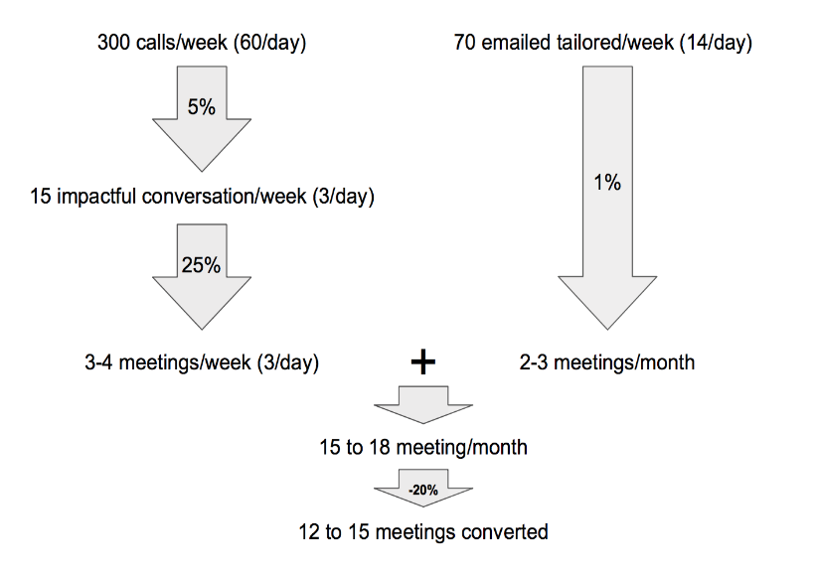

# SDR Alignment

[Link](https://docs.google.com/spreadsheets/u/0/d/1AQ-8rrPtG56QmtGh7PT87uOUJVm6og67adDUezaogdA/edit)

This alignment sheet is for us to be able to plan and discuss SDRs function growth based on the number of AEs.

It is also for us to be able to have a global vision of the alignment and plan it further.

It will help us to break down future geographical growth plans for AE and SDR.

This sheet should be shared with other Sales Leaders, Recruitment, and Finance for headcounts budgeting and investment.

# SDR PERFORMANCE

SDRs are able to follow their monthly progression and performance (number of meetings taken, connections, calls, emails, linkedin messaging) via dashboards in SFDC.

The leadership team will track these activities in order to adjust SDRs training and track quota attainment for commission.

# SDR CADENCE

# #1 priority for SDRs is to be organized.

* Your weekly cadence will determine how efficient you will be.
* Leverage tools (like Hubspot, Groove if we get it, to organized your day)
* Sales navigator

Example of cadence:

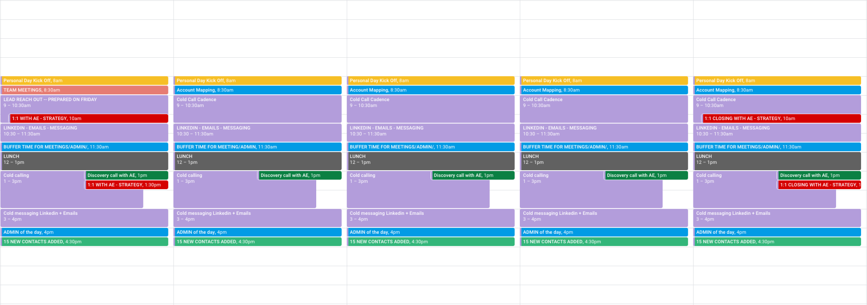

As SDRs are aligned with AEs, it is important for SDRs to meet on a weekly basis weekly with their AEs to plan for the week and build a strategy to break into the account selected.

SDRs are responsible for scheduling meetings by blocking time on their AEs calendar.

It is best practice to schedule your weekly 1:1s on Friday or Monday to plan for the following week. SDRs and AEs may extend those 1:1 sync to twice per week in order to plan for the week but also review what went well and what should be improved.

SDRs should attend global team meetings and sales opportunities review to ensure they are on the same page as the team they are supporting to understand the full sales cycle.

SDRs are expected to meet weekly with their Managers to review quota attainment, daily / weekly / monthly metric attainment.

Managers will work closely with their direct reports to identify what went well in order to continue using what is bringing value to the business but also to identify what is falling short.

SDRs are also expected to attend weekly team meetings led by their managers.

SDRs Cadence should include:

* SDR team meeting weekly kick off
* SDR/AE weekly sync
* **PG (pipeline generation)/Outbound**

1. Based on AEs targeted account and strategy establish, SDRs need to do the research
2. Reach out to different personas and enrich SFDC
3. Leverage sales tools (sales navigator, automation campaign tool, cadence for touch point, ring central, gong)
4. Be able to disqualify an account and share these reasons with the AE
5. Apply our sales methodology: MEDDIC (metrics,economic buyer, decision maker, decision process, identify pain, champion)
6. Confirm a strong use case / Identify potential pain
7. Potential champion
8. Potential next step
9. And explain to AEs why they should be taking this call/meeting

* Inbound

1. Follow up with Marketing Qualified Leads (MQLs). All inbound reach out should be based on research and understand who the SDR is contacting (Persona, latest News and be audible ready to pitch and handle objections)

SLA for the first touch point is 2 days maximum.

1. Before any reach out SDRs should make sure it is not already being worked by any AEs. Thorough communication between SDR org and AE org should be the norm
2. SDRs are required to qualify all inbound leads once you have made contact with them. Identify use-case & pain.

* SFDC hygiene

1. SDRs are required to maintain a clean & accurate record in Salesforce
2. SDR leaders leverage SFDC reports to track activity, make sure your activity tells a good story but also to identify any area of improvement
3. If you’re hitting your goal, your activity must show how
4. If you’re missing your goal, your activity will tell you a way to ﬁx it

# DAILY ROUTINE

The activities you should do every single day in order to be performing:

* Check and sort your emails → in order to not miss any emails from prospects and inbound leads
* Complete all your tasks in your cadence and salesforce
* Prospection

1. You should aim to send tailored emails
2. You should aim to add 15 to 20 new contact on your call cadence
3. You should aim to have the number of connects in mind
4. You should aim to reach your calls target

* Have dedicated hours for power hours: Hyper focus on 1 task. In general, we recommend this for calls and tailored emails

Tips:

* Snooze slack during power hour
* Cell phone notifications off
* Block calendar
* Be ready to take notes during meetings. Information is crucial for AE and making the opportunity to progress
* Set goals and be accountable.
* Right attitude. Sales is all about up and down.

Tips:

Be confident

Stay positive and never end on a bad call

Stepping back is crucial

Communicate thoroughly with manager

Focus on what you can control

Never take any remarks personally coming from prospects

# SDR & AE COLLABORATION GUIDELINES

The SDRs mission is to act as a support and partner with the AE. SDRs support is based on acquiring new business meetings (NBM)

These NBM should be prequalified according to the MEDDIC sales methodology.

As a matter of fact, AEs who own the account should be able to share the strategy, guidance and reasons for going after a specific account. All this in accordance to their prospecting plans.

Ex: Bottom up strategy or Up to Bottom strategy

Rules of Engagement

1. AE and SDRs will need to meet (at minimum) once per week.

Goals of the/those meeting(s):

1. Discussed targeted account strategy
2. Value drivers for the account has to be shared with the SDR
3. AE & SDR should be clearly identified the “3 Why” : “Why now” – “Why you” – “Why do anything”
4. SDRs should come prepared to share all actions taken such as, numbers of reach out, example of messaging, list of personas etc.
5. Thorough communication should be happening between SDRs and AEs in order to avoid duplicate reach out and poor customer experience

2. SDRs should attend meetings with AE and also be invited by AEs to conversations with clients

3. SDRs must wait 6 months before working on any closed lost opportunity or churned customers

4. Each AE aligned with an SDR should provide up to 4 accounts for SDRs to work on.

5. SDRs should be able to disqualify an account after following the account cadence and share a valid explanation why the account needs to be disqualified for now.

6. Accounts should be a mix of Tier 1, Tier 2 and Tier 3 accounts and not only Tier 3 accounts that AE didn’t have any traction

7. Enterprise AEs should push Marketing leads down to SDRs for potential qualification if they are the owner of the account and this is only at the AE’s discretion.

8. If Enterprise AEs crack into accounts that SDRs worked with them, SDRs will receive quota credit if they have the appropriate level of activity (10 to 12 touchpoints)

9. AEs should be sharing their agenda with their SDRs in order to facilitate meetings booking.

10. AEs & SDRs should communicate with each other via slack, emails or Linkedin

11. SDRs should be sending to their manager a weekly recap of prior week:

* Discovery meetings scheduled
* Opportunities created
* Companies disqualified and reasons
* Success and challenges
* Strategies that was used
* Plan for next week (new target accounts if any, personas)
* Sharing PTO, events etc

# SDR COLD CALL TRAINING

1. What do you need to aim for and why ?

* **YOU** are in control!
* So make sure you have a plan and a goal.
* There is ALWAYS only 1 goal…

BOOK A MEETING!

* Aiming for the right attitude is also part of the preparation

***How* you speak is just as important as *what* you say**

* Clean Speech: avoid filter words like ‘um, ah, like, you know, right”
* Pace: slow down, fast pace creates anxiety and distrust
* Tone: conveys emotions
* Volume: higher than normal, this expresses confidence & credibility
* Energy: be aware of your energy level and actively manage it

1. Anatomy of a perfect cold call

**These are the following steps to follow**

1. Get someone to listen/pay attention
2. State the purpose of your call/ Why are you calling them
3. Explain why you’re relevant/important
4. Ask for the meeting
5. Explain why you’re relevant | important (with more detail)
6. Ask for the meeting

3. Making the call

There are 4 clear steps that the SDR needs to master

1. Getting the prospect attention - after interrupting them

You are interrupting your prospect. Your call isn’t expected or desired

An opening line that breaks through the clutter, avoids confusion and gets the person focused on your ask.

“Hi [First name],

This is [SDR name] from Tetrate. We haven’t spoken before,

but I’m hoping you can help me.

The purpose of my call is to set up a meeting with you [or Company]/

1. Do you have a minute so I can share with you why?”

Or use:

1. “Would it be okay for me to explain why and then you can let me know if you’re open to it?”
2. **Goal: Getting the first YES**

Asking permission gives the prospect of feeling in control.

“Would it be okay for me to explain why and then you can let me know if you’re open to it?”

30 Seconds Commercial + References + Ask

A non technical description of Tetrate, who we work with & problems we solve. 1 to 3 references based on the vertical

“Great! Before I jump into it… just curious… Are you already familiar with Tetrate?”

<wait for response>

Great so… Tetrate helps to configure connectivity, security and observability for your entire application network.

In one single pane of glass you will be able to increase business agility with high security and focus on Business continuity.

We work with a number of [Vertical name] companies, including [Customer] and [Customer].

Would you be open to discuss further next week Tuesday at 2 pm or Thursday at 3 pm ?

<wait for response>

1. **Tell them more**

*Paint a clear picture of how Tetrate fits, using persona based before statements and positive business outcomes*

“Sure. Those companies I referenced were really struggling with [Before Statement].

Tetrate allowed them to [Positive Business Outcomes].

At this point, I’m not an expert on your business, but based on my initial research I believe we can provide similar value to you and I’d love to explore in a follow-up conversation.

1. Call to action

→ Ask for a meeting: call to action with 2 time slots

Ex: Would you be open to discuss further next week Tuesday at 2 pm or Thursday at 3 pm ?

<wait for response>

# LEAVING A VOICEMAIL

Should we leave voicemail? The answer is YES

→ Nevertheless 98% of voicemail fail in the first second

If 98% fail within the first second … we need to be creative!

So … DON’T start with your name!

Don’t:

* Don’t expect (or even ask for) a call back
* Don’t take forever
* Don’t leave one after every attempt

Script 1:

SDR:

Hi [Prospects name], I read reviews (google) from your customers highlighting that your company’s mobile app has performance issues. I am reaching out to you to set up a meeting so I can share how we could add value to your company/organization and help you with [improving current state and creating positive business outcomes].

By the way, I am (SDR name) from Tetrate. I will try to reach out to you another time and follow up with an email. Please also feel free to reach out to me directly.

Script 2:

Hi [Prospects name],

I’d like to schedule a quick call to discuss how we can partner with [Companies XYZ] to improve security and observability across your microservices.

This is [SDR Name] from Tetrate and we’re working with major companies and governmental institution

to [value driver, value driver] by [improving current state and creating positive business outcomes].

I would love the opportunity to chat with you about it, if you’re open and feel it’s relevant.

I’ll send an email shortly with my contact info and look forward to connecting soon.

Do:

* Always follow-up with an email
* Focus on your tone and be confident
* Your messaging is relevant & compelling

# SDR OBJECTIONS HANDLING TRAINING

Handling Objections Structure

**Step 1: CUSHION/ EMBRACE**

* Let the prospect know you heard them and accept it - repeat it. Don’t try to win the prospect over or imply that you think the objections is invalid or unreasonable

**Step 2: INFORM**

* Share something about our product that is related to what they have said

**Step 3: QUESTION**

* Ask an open-ended question about the objection to extend the conversation and continue the conversation

Blocking objections

Objections are almost always the same.

SDRs need to get ready and learn how to answer these objections. It’s a matter of preparation.

* Most common objections:

1. I don’t have time right now
2. I’m not interested | not in the market
3. Already committed to another vendor
4. I’m not the right person
5. I don’t have budget
6. I don’t take sales calls
7. Send me an email
8. How did you get my number?
9. What’s this all about?
10. How are you different from __________?
11. **I don’t have time right now / No time to talk**

* Ask for 5 minutes tomorrow or a quick question
  + If there is urgency in delivery: “Oh, I’m sorry I caught you at a bad time. How about 5 minutes this time tomorrow?
  + If no real urgency: “Oh I’m sorry I caught you at a bad time. Would it be ok if I ask you one question?
  + Asks for a call back: “I understand you’re busy. In fact most of the software engineers we speak with are spending their time and energy chasing down connectivity problems.

Our platform helps eliminate a lot of this unnecessary stress and let you focus on more proactive ways to impact the business.

It would only take 20 minutes for you to determine whether Tetrate will benefit you like it has [customer]. I’d like to schedule some time in the next week if we could… How about [date / time]?

1. **I’m not interested | not in the market**

* It means the prospect know you want to sell him/her something

“I get that. Can I just ask while I have you on the phone, for my own education… when I’m talking to engineers and they tell me they’re ‘not interested’ / ‘not in the market’ it seems to be one of the reasons:

1)They have a tool already in place

2)They haven’t really had connectivity and security issue with their application network

3)Or I just caught them at the wrong time and they can’t talk…

Is it one of these or is it something else?”

1. **Already committed to another vendor**

* It also means the prospect knows you want to sell him/her something

“That’s great to hear!

* Can I ask what you are using?
* How long have you been using that?
* Why did you choose that provider in the first place?
* Are you happy with how it is working for you?
* Out of curiosity, is there something you particularly like about it?
* Anywhere where it comes up short?”
* On a scale from 1 to 10, how satisfied are you ?

1. **I’m not the right person | Wrong person**

* Ask who the right person is and ask about what they do

“Oh, I’m sorry if you’re not the right person to speak with about this.

As the [Title] you fit the profile of a lot of people we work with who are interested in optimizing their application management and network.

Scenarios:

1. Who typically is responsible for organizing your microservices environment?
2. While I have you on the phone, can you tell me a little more about your role and responsibilities?

**5) I don’t have budget**

* Reassure / Relax them; tell them you’re not trying to sell them anything

“I can totally understand that. I’m actually not trying to sell you anything.

We’re contacting companies like yours to let them know about Tetrate, an application network tool for hybrid and cloud IT, that enables you to boost connectivity, strengthen security, and prevent critical bugs in a single and unified platform.

Can I ask… how do you currently manage your application network?”

**6) I don’t take sales calls**

* Relax them as they know you want to sell them something; tell them you’re in sales development /or discovery team

“I can totally understand that, I’m actually part of the sales development team here at Tetrate. I’m hoping you can help me.

[pause]

The purpose of my call is to set up a meeting with [Company]... go into cold call script”

**7) Send me an email**

Scenario 1:

* “Happy to send information your way… we have several case studies about how we’re giving engineers full visibility across their application network… which could take some time to read.

You know, most of our customers find that with a brief call, say 10-15 minutes, they get a pretty good idea of what we do. Can I set that up for you?”

Scenario 2:

* “Sure, I can certainly send you information. I want to make sure I send the information that's going to be most useful. Can I ask what is it that you’re most interested in? <wait for a response> I’m curious, why did you want me to send that? <wait for a response>”

Scenario 3:

* “Sure, can we agree to reconnect to review this next week? That way I can answer any questions you might have.. What is the best time to schedule that follow up?”

**8) How did you get my number?**

* “I came across your number online and am reaching out because… [30 Second Commercial from Cold Call Script]”

The idea here is to go straight to the cold call script and avoid too many explanations.

**9) What’s this all about?**

* “Sorry [Firstname]. I’m [SDR name] with Tetrate…

Tetrate helps developers and engineers to manage their application network.

Tetrate provides the ability to be able to keep their business agility, secure the network and ensure business continuity with their application network.

The reason for today’s call was to learn how your team is managing your application network and see if it would make sense to carve out 20 minutes this week to share how our tool is helping engineers/developers in your industry bring all they need into a single spot.

How about [date / time]?”

**10) How are you different from (Competitor)?**

Tips: Never argue about the competitor

* “That’s a great question! [Competitor’s name] ] is a fine tool for [category name].   
    
  I’m not an expert in their technology - nor would I ever pretend to be - but, my understanding of their tool is [Competitor’s View of World]... we are a little different because [Competitor’s View].  
    
  I am happy to set some time to dive into these differences more.

Rather than launch into a full demonstration, would it make sense to set 20-30 minutes when you have time to discuss what you’re experiencing and see if its even a challenge we solve?

Does [Date / Time] if that works for you?” → Always propose 2 time slots

# SDR GATE KEEPERS TRAINING

Please make sure the GATEKEEPER is an ally to your hunting reach out.

Tips:

* Act like a professional
* Be confident about why your are reaching out
* Don’t give an “all in” introduction
* Know you Gatekeeper and build rapport with the person
* Be accountable
* Come prepared

**Send me an email, and I’ll pass it along**

* “I really appreciate you offering to do that. It’s actually really important that I speak to them directly. When’s a good time to reach [prospect’s name]?”

**Try back another time | He/ She is not available**

* “I’d be happy to. When’s a good time to catch them in the office?”

**What’s this about?**

* “I have some important information about [value driver]. How about I call back this time [date]?”

**Ask for the Gatekeepers first name**

* “You’ve been really helpful. Who am I speaking with?”

**Call back exactly when you say you will. Remind the gatekeeper of the conversation you had.**

* “Hi [Gatekeeper’s name], I spoke to you last [date], this is [SDR name] from Tetrate. You said this would be a good time to reach [Prospect’s name]. Is she/ he available?

**Repeat yourself**

* “Hi, this is [SDR name] for [Prospect’s name]”

If they ask who? <repeat yourself> “This is [SDR name] for [Prospect’s name]” <wait>

# ELEVATOR PITCH – 30 SECONDS

1. Always relate your elevator pitch to a real life situation that anyone could experience
2. Be brief explaining information

**Situation: Meet a CxO at a conference, the CxO is asking you what exactly is Tetrate doing?**

“When was the last time you opened up the mobile app from your bank and tried to get something done? And it was buggy and looks outdated?

Imagine a world where your bank can roll out improvements to its mobile app weekly

Well, Tetrate helps companies to make sure that deploying apps is fast, secure, and easy for dev and infrastructure teams, at banks and organizations across industries and sizes

# EXTENDED ELEVATOR PITCH

Tetrate was created in 2018 by two key founders of Istio and Envoy. Both founders built the infrastructure at like Google and Twitter. They created Tetrate to help every company secure and scale infrastructure based on their lessons learned.

A fundamental shift is happening where developers are moving from monolithic architecture to cloud native microservices based on container deployments. Gartner estimates that more than [85% of global organizations](https://siliconangle.com/2020/10/09/top-5-enterprise-questions-containers-kubernetes/#:~:text=In%20fact%2C%20by%202025%2C%20more,fewer%20than%2035%25%20in%202019.) will be running containerized applications by 2025, compared to fewer than 35% in 2019

As a result, building and deploying microservices is becoming more complex from moving to one or more clouds and different deployment environments. Organizations struggle to securely deploy and maintain microservices in such complex environments.

Tetrate is already leveraged by numerous organizations such as DOD who needed to secure and observe their microservices

Other clients such as Visa have to make sure of their business continuity on the top level.

In fact millions of end users are depending on Visa’s payment services.

Gartner recognized Tetrate as a Cool Vendor because Tetrate is enabling organizations to deploy applications faster, more securely and achieve more resilience through an enterprise-ready service mesh. Tetrate delivers a unified platform complete with training, services, and support. We are trusted by federal agencies and leading financial institutions.

Who is ready for the next era of technology?

# SALES PROCESS

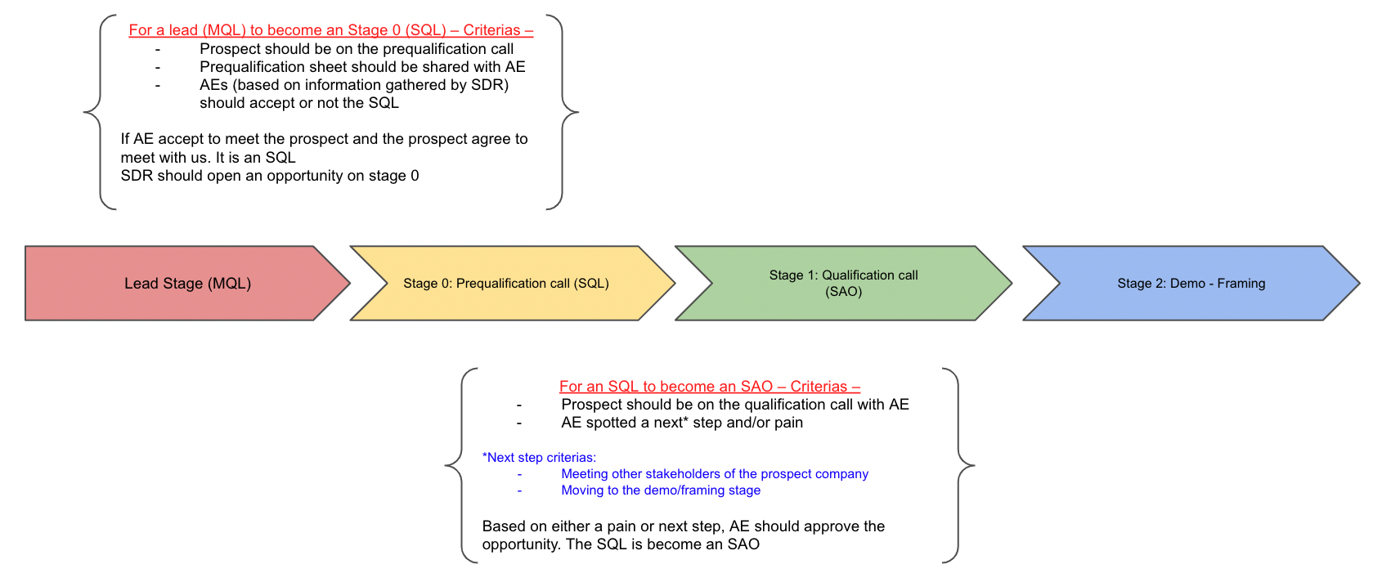

|  |  | LEAD: Pipeline generation (MQL) - Connect Stage | Stage 0 : Prequalification call (SQL) | Stage 1: Qualification/Discovery call (SAO) | Stage 2: Demo - Framing | Stage 3: Proving | Stage 4: Proposal and Negotiation | Stage 5: Finalizing contract | Stage 6: Close Won |
| --- | --- | --- | --- | --- | --- | --- | --- | --- | --- |
| Stage owner | SDR | YES | YES | ATTENDANCE ONLY | ATTENDANCE ONLY | ATTENDANCE ONLY | ATTENDANCE ONLY |  |  |
| AE | NO | OPTIONAL | YES | YES |  |  |  |  |
| SE | NO | NO | NO | YES |  |  |  |  |
| Stage exit criteria |  | SDR must achieve x, y, z with MQL to mark as SQL  LEAD STAGE TO STAGE 0  NOTE FOR AN MQL TO BECOME A SQL. SDR MUST AT THE END OF THE PREQUALIFICATION CALL TO BOOK A MEETING WITH THE PROSPECT FOR AE | | AE owns this onwards | AE owns this onwards | AE owns this onwards | AE owns this onwards | AE owns this onwards | AE owns this onwards |
| Stage exit criteria |  |  | STAGE 0 → STAGE 1 → STAGE 2  NOTE FOR AN SQL TO BECOME A SAO. WHEN QUALIFICATION CALL IS COMPLETED BY AE; AE SHOULD APPROVE OR NOT ACCORDINGLY IF IT IS AN OPPORTUNITY or NEXT STEP  SAO IS CONFIRMED ONLY AT THE END OF THE QUALIFICATION CALL  NEXT COULD BE A DEMO/ FRAMING OR INTRODUCING OTHER PEOPLE FOR OTHER CALLS | | |  |  |  |  |
| Stakeholder actions |  | SDR Cold calling & Cold Messaging inbound leads and outbound | At this stage SDR should be able to gathered all informations needed for AEs (accordingly to the [prequalification sheet](https://docs.google.com/document/u/0/d/1U2F5WQYKGsRhAvduDf6FSkzWONn1MgxpciP8KTOQ14E/edit)) | AE conducting discovery call and SDR should attend (if possible) | This stage is for proving value | SE giving a deeper knowledge | AE sending proposal |  | AE should share with all Tetrand the win report |
|  | Goal of cold reach out: Get the prospect to accept a "First meeting" in order to prequalify if there is a POTENTIAL fit | It is NOT a discovery call but to understand prospects current situation  **[pre-discovery call SDR quota]** | AE deep dive with MEDDIC sales methodology |  |  |  |  |  |
|  | SDR need to strategize with AE | MEDDIC: Potential Pain | MEDDIC: ID Pain | AE would like to partner with Sales Engineers |  | Negotiation on: Legal, Security, Pricing |  | AE work with CSM to help for future rapport |
|  | Tailored reach out (Cold Calling and messaging)  Established contact are called “Connects”, not quote’ed, but tracked as KPIs | MEDDIC: Potential Next Step | MEDDIC: Generate Next Step | SDR should be participating to those meetings |  |  |  | AE should schedule Health check |
|  | Build Personas List on Sales Navigator and sharing with AE + Manager | MEDDIC: Potential Champion | MEDDIC: Qualifying Champion | Pre sales Engineers |  |  |  |  |
|  |  | MEDDIC: being able to tell Why AE should take the next call -- If there is a potential fit for next step | AE should know at this stage why they took the call |  |  |  |  |  |
|  | Follow cadence reachout | AEs if possible would join the prequalification call -- It is only at the AE discretion to come to a prequalification call |  |  |  |  |  |  |
| Tools |  |  |  |  |  |  |  |  |  |
|  | Linkedin sale navigator | Discovery questions | Sales pitch deck | Demo deck |  |  |  |  |
|  | Cold call training script | Marketing Pitch from [deck](https://docs.google.com/presentation/d/1Fy_r2qF9JwAYxBMZ5yrrz0DC9jXMsGSGXzuSxLhZrAU/edit#slide=id.g155e806dc0b_0_2499) | Marketing pitch from [deck](https://docs.google.com/presentation/d/1Fy_r2qF9JwAYxBMZ5yrrz0DC9jXMsGSGXzuSxLhZrAU/edit#slide=id.g15a3b89fd97_0_1481) | Sharing platforms |  |  |  |  |
|  | Messaging training | Success story use cases | Success story use cases | Answering technical questions |  |  |  |  |
|  | Email templates |  |  |  |  |  |  |  |
|  | Personas training |  |  |  |  |  |  |  |
|  | Automation flow tools |  |  |  |  |  |  |  |
| Next step |  |  |  |  |  |  |  |  |  |
|  | Interact with prospects for the first time | If prospect shows up to the meeting: | If a prospect shows up to the meeting and if at the END of the discovery calls the AE spot an opportunity, AE should approve the SAO stage. | Matching pains with Tetrate's Value Driver |  | Get the approval from client |  |  |
|  | SDR Inform AE on progression | - After the call SDR open a stage 0 Opportunity | End of SDR ownership at the end of this call | Share the cost |  | Get approval from client to use the success stories |  |  |
|  | Goal: get a 15/ 20 min call for prequalification and make it an SQL | - SDR inform AE on progression |  | Get Champion to commit in the deal |  |  |  |  |
|  |  |  |  |  |  |  |  |  |
|  |  |  |  |  |  |  |  |  |
| SFDC Actions |  | Report new contact (connect) | If potential fit SDR needs to create an opportunity with stage 0 | AE will approve or not if this lead is an SOA | AE adding Demo note and questions form prospects |  | Update deal informations such as contract amount and duration | Insert all paper work on salesforce ?? |  |
|  | Open a pre qualification meeting | Take note in SFDC | If AE approve the meeting, this SQL become an SAO for the SDR | Visibility on why prospects will use our solution |  |  |  |  |
|  |  |  |  | What will our solution will solve |  |  |  |  |
|  |  |  |  |  |  |  |  |  |

# DISCOVERY QUESTIONS BANK

## Personas related

* What is your current role and responsibilities ?
* What KPIs are your teams measured by?
* In your company, what’s the process to buy or procure a new software / tool?
* What are the typical daily activities when you are on the job?
* On your daily work routine, what would you improve?
* What’s the least valuable / favorite activity in your day-to-day life?
* What is the most important thing for you to achieve on a daily basis?

## IT environments related

* Can you describe what your IT Infrastructure looks like?
  + (Follow-up) How long have you been using Kubernetes (we need some kubernetes expertise)
* Have you evaluated service mesh or Istio?
* What are the major initiatives in your team?
* With the current tools, on a scale from 1 to 10 how would you rate them?

Continuing:

1. Why?
2. In an ideal world how would you improve it ?

* Why are you using this or this cloud provider?
* May I ask you why you have different cloud providers ?
* How much has your IT environment changed since the past 6 months/ year ?
* What are the big challenges for the next 6 coming months?
* You are working with microservices, how would you rate your security?
* You are migrating to the cloud, how is it going so far ?
* Why are you migrating to the cloud?
* What makes you do those changes?

### What are you currently spending to solve your IT problems?

### Who else would love to see this problem solved?

## Business related

* When is your project due?
* What do you think your company is doing well in terms of infrastructure? (follow up question)
* What do you think you should improve?
* What does the decision process look like?
* Who is responsible for approving a new vendor?
* What’s the impact for your business to not solve this problem?
* What would happen if you don’t do anything about this problem?
* When do you see yourself putting a solution in place?
* Who else needs to be involved in the call to hear about this?
* What do you want us to include in our next call?

# SDR RESEARCH ACCOUNT

Mapping Spreadsheet to download [here](https://docs.google.com/spreadsheets/d/1HVll51F9IFiAjSrxwGnboq2DHVzZQlL6GdewMA3N_Xg/edit#gid=0) – Make a copy for each account –

Step 1 : What does the company do? (Why you? Why now?)

* Business Insider
* Google alerts
* Sales navigator
* Company’s website

Step 2: Identify current tool stack:

* Stackshare.io
* BuiltWith
* Sales Navigator

Step 3: Look for the open job postings in the IT Department

* Look at open jobs on website or Linkedin or Indeed

Step 4: General Research

* what press releases
* products they are building
* Services they are offering
* Any mergers or acquisitions
* Annual Revenue/ financial report

Step 5: Leverage information in Salesforce

A. Look for any Closed-Lost opportunities. Why was it Closed-Lost?

B. Look for any link with AE

C. Look at the Activity History - connects/ meetings set/ qualification calls

D. Link all the other existing contacts from the same company

E. Identify the business units

F. Identify the contacts that you’d like to target - Create sales flows and lead list on sales navigator

Step 6 Keep salesforce updated with the newest information on contacts:

* like job title
* Email
* phone

Step 7 Update contact status for every contact

Step 8 Find Net New Contacts via LinkedIn/ ZoomInfo

* Starting with a target of 15 - 25 contacts
* Keep adding people in your sales cadence everyday (15 new contact everyday)

Step 9 Connect on linkedin,

* add those contacts only after they are engaging with you

# VALUE DRIVERS

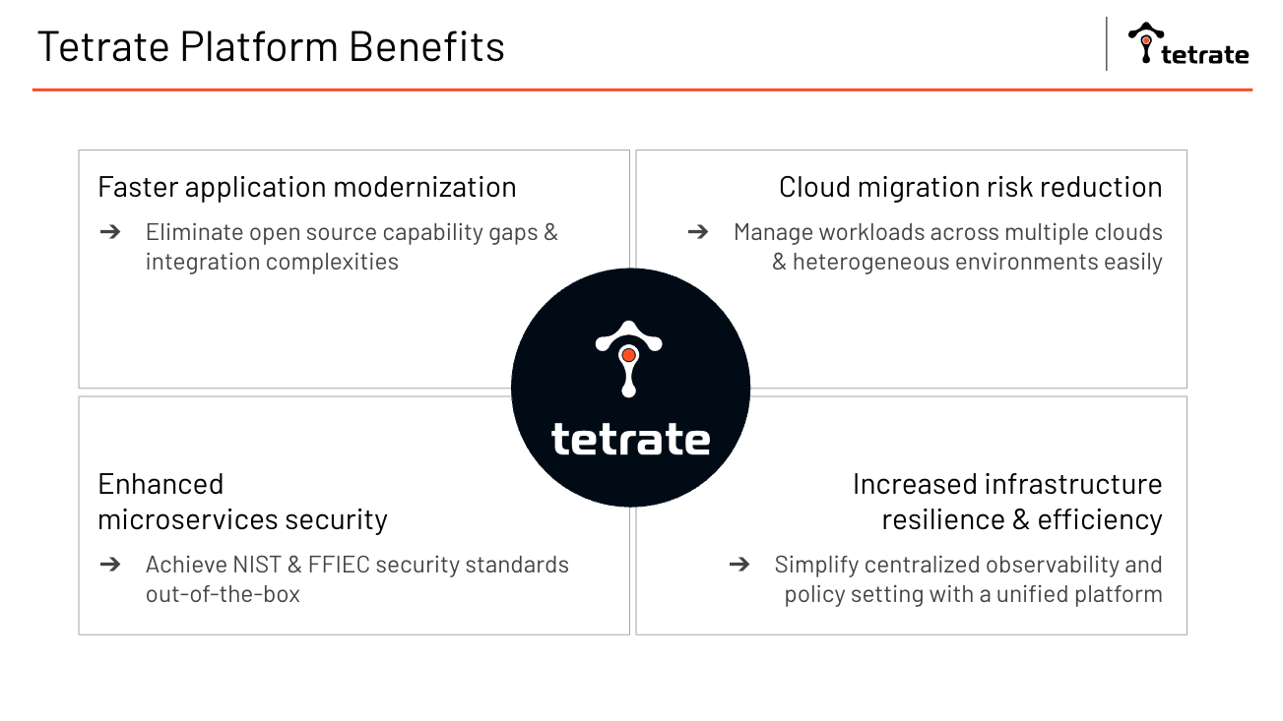

Source: [Tetrate 101 pitch deck](https://docs.google.com/presentation/d/1Fy_r2qF9JwAYxBMZ5yrrz0DC9jXMsGSGXzuSxLhZrAU/edit#slide=id.g160d1444aa4_0_886)

# SUCCESS STORY: Before scenario and the after scenario

| Customer: Visa | |
| --- | --- |
| **Before scenario** | * Visa wants to launch new payment services and customer experiences faster through acquisition and homegrown innovation. —> 1) * Acquired 9 fintech startups, with varying tech stacks and cloud environments. |
| **Negative impact** | * Slow innovation & poor customer experience: Launch new software only 1x / year —>2) * High risk of security breach: Cannot centrally define, execute, and audit policies →3) * Behind their modernization schedule: M&A complexity slowing down modernization initiative   → 4) |
| **After scenario** | * Visa modernizes application deployment with more speed and security * Acquired tech stacks fully integrated in overall infrastructure |
| **Positive impact** | * Visa BUs get new services and functionalities faster * Auditable proof in achieving microservices security standards * M&A realizes full promised value |
| **What Tetrate did** | * Tetrate’s enterprise-ready service mesh platform as the single point of application deployment management and security across all it’s public clouds, private clouds, VMs, and container environments. |
| **Metric** | * Visa achieves modernization timeline 2x faster * Visa now launching new services 4x / year (4x faster) |

# SALES FLOWS

Tetrate is offering a first class solution nevertheless brand awareness is an area of improvement. Therefore as an SDR your first mission is to get the prospect's attention and get him/her to listen.

For that it is important to have a strong reason to call.

Before reaching out you need to be able to rely on something either you have done before or an action that the prospect has done.

Example:

* You reaching out before via emails/ linkedin → “I have sent over an email yesterday”, or “linkedin connection”
* The prospect (persona) got a promotion
* Get yourself introduce by someone
* Having someone in common in your Linkedin network, Same school

Example of work flows:

Always start with Email and Email + Linkedin





# SDR PRE QUALIFICATION SHEET

**https://docs.google.com/document/d/1S2kcJuJZSQC4vRsb6QihPJerHTcDtiopzsk_42dmGlc/edit#m**

# SDR QUOTA

| **WIP**  SDR KPIs monthly per SDR | Per month | Per quarter | Comp |
| --- | --- | --- | --- |
| SQL-20-min pre-qual meeting  (AE optional) | 12 | 36 | 50% |
| SAOs-  approved after 30-min qual meeting  (AE mandatory) | 6 | 18 | 50% |
|  |  |  |  |

# KNOW YOUR COMPETITOR

| **Competitive Comparison Matrix: Tetrate vs Redhat vs Tanzu vs Anthos** | | | | | | | |
| --- | --- | --- | --- | --- | --- | --- | --- |
|  | **Istio OpenSource Steering Comittee** | **Latest Istio Supported** | **Cross Platform Support** | **Multi Tenancy / Security** | **Multi Cluster and HA** | **Active Development and Future Proof** | **Additional Resources / Comments** |
| **Tetrate** | Yes | Yes, n, n-1, n-2 | Hybrid Clouds, Compute Anywhere | Tetrate Istio is the only build that comes with FIPS / PCI DSS Compliance (Hardened Istio) | Fully Support - Cloud and Platform Agnostic | Tetrate specialised and focussed only on Service Mesh and helping customers in adopting mesh (Istio and Envoy) | Provides Free Istio Foundations Training and Certification |
|  | Istio, Envoy and Skywalking Founding Engineers are part of the core Founding Egineers in Tetrate | Full features supported upto latest versions | Workloads supported on VM's, Baremetal and K8s across any cloud providers including OnPrem | One click - enable Default Security across clusters / multi clouds | No Vendor Lockin | Tetrate Service Bridge - Management Plane to manage multiple Istio Control Planes across clouds | Provides Advanced Istio Administrator Training and Certification |
|  |  |  |  | Multi-Tenancy that can be applied at Customer Org or App Org structure. Workload Seperation across clusters by grouping them into Workspace | HA / Failover across multi-cluster | TSB makes VM oboarding much easier for migrating VM and Legacy workloads into Service Mesh |  |
|  |  |  |  | (Workspace = collection of clusters / application groups across clouds) | TSB allows central management of multiple Istio Control Planes, Configuration, Traffic Control, Security Policies and Observability | TSB allows consisten policy deployment and control across multiple clusters |  |
|  |  |  |  |  |  |  |  |
| **RedHat** | Yes | Latest version supported is n-2 | Only OpenShift Container Platforms | No hardening | Works only with Red Had Enterprise Linux. Tied to Openshift. Multi-cluster support is partial | Service Mesh is not a main product, Mostly are focussed on Openshift Clusters and broad Linux portfolios | Paid Training mostly covers broad Kubernetes and small part of Service Mesh Theory |
|  |  | supported version missing many features / patches | No VM Support | Multi-Tenancy at Namespace | There is no Management Plane to handle multiple Istio Control Planes |  |  |
|  |  |  |  |  |  |  |  |
|  |  |  |  |  |  |  |  |
|  |  |  |  |  |  |  |  |
| **Tanzu** | No | Latest version supported is n-2 | Tanzu K8s, Grid, K8s | No hardening | Build on NSX and available on VMware Cloud Services | Service Mesh is mostly an after thought, the focus in on very broad portfolio of VMware Cloud platforms and Virtualization | Dependency on VMware Cloud Services that may not be cost effective compared to Public Cloud Vendors. Service Mesh is Tied to NSX platforms |
|  |  | supported version missing many features / patches | No VM Support | Multi-Tenancy at Namespace | There is no Management Plane to handle multiple Istio Control Planes | VMWare centric customers with tight future alignment with VMWare technologies | Service mesh is a small part of other broad platform training |
|  |  |  |  |  |  |  |  |
|  |  |  |  |  |  |  |  |
| **Anthos** | Yes | Managed Istio Service by Google | Primarily GKE, supports AWS and On Prem GKE Clusters | No hardening | Dependency on GCP Cloud Logging and Cloud Monitioring to manage the clusters | Cannot customise, not extentable as its fully managed service by google | Dependency on GCP Infra and several services to manage clusters |
|  |  |  |  | Multi-Tenancy at Namespace | Cluster can be in AWS or On Prem but clusters have to be managed through GKE |  |  |
|  |  |  |  |  |  |  |  |
|  |  |  |  |  |  |  |  |

# SDR ELIGIBILITY TO PROMOTE TO AE

Tetrate values career progression and empowerment. We have a clear path for SDRs to progress within the company.

In order to become eligible for a promotion, the SDRs should be able to share a successful track record and fulfill all the criteria set by the company.

Eligibility* criteria:

| Time minimum within the company | 1 year |
| --- | --- |
| Numbers of meetings | 150 |
| Sales accepted opportunity (SAO) | 80 |

*please note that eligibility doesn’t mean automatic. Below SDR will find the step to become AE.

As well as eligibility , the SDRs will need to pass:

* the “Director role play”. SDR will be given a specific scenario and will need to be able to run a full discovery call.
* An internal interview
* Open headcount for an AE position and business need for this specific role

# SDR 1:1 SPREADSHEET [(download here)](https://docs.google.com/spreadsheets/d/1oG5N-p14M8dCv7HsWbMLXC0N5G7z7vmmNVjiURYb_Is/edit#gid=968835449)

Each SDR must download this spreadsheet and use it during his/her 1:1 with his/her manager.

In fact, it’s a spreadsheet that SDR must fill in before their 1:1. It will help the SDR and their manager to have a clear understanding of their quarter performance.

It shows the number of SQL and SAO booked so far during the quarter. The manager will also be able to help with roadblocks that the SDR is facing on a specific account.

Please download the spreadsheet and make a copy under your name.

# USEFUL LINK

1. Google Alerts

SDR may use “[Google Alerts](https://www.google.com/alerts)” to get daily information automatically. It is very easy to use and to adjust.

SDR simply needs to add keywords on subjects they would like to get information about.

It will help the SDR to optimize their research time and get meaningful information on the business and IT environment of their targeted account.

SDR will be able to define how often they want updates, the language and specific region

Example:

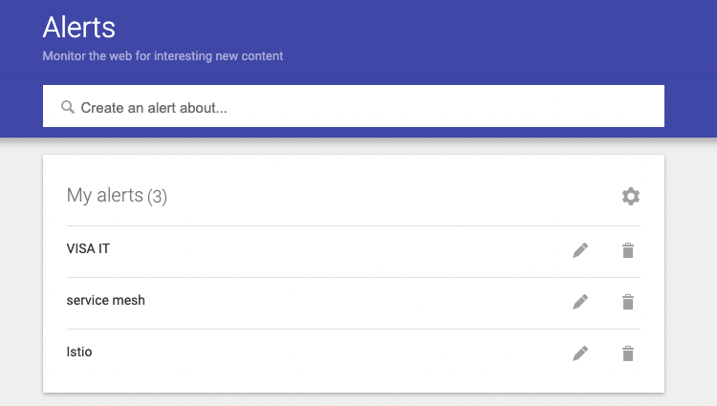

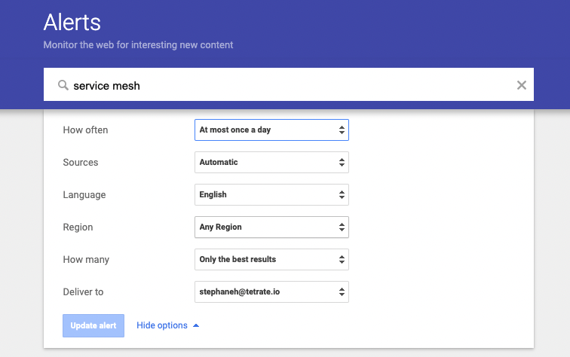

# MESSAGING - EMAILS

Messaging is an art and because we are going after prospects who are receiving hundreds of emails per week; the more tailored it is the better.

SDRs should do email based on their research and bring a personal touch

Let’s start with the subject line. It should be creative, brief and spark your prospect's curiosity.

Writing a good subject line isn’t easy as it has to be updated all the time.

## Subject Liner

### 1. Be Brief.

Subject line varies between mobile, desktop, and tablet devices, so keep this in mind as you craft the perfect one-liner for your sales email.

On average, the maximum subject line is about 60 characters long before it gets cut off by the email provider.

In the SDR world we suggest 40 characters so that each word appears on desktop, mobile, and tablet devices.

### 2. Personalization

In terms of personalization, we should be able to relate the subject line to either the person’s name and/or the subject you read about their company.

Ex:

* Media/article
* Linkedin connection
* Contact introduction
* [If lead is from inbound] relate to their actions

The idea is to make it about “them” not you.

People want to hear from, talk to, and buy from other people, not from big brands and companies.

### 3. Make it interesting

Make it interesting because, even if you write the best email in the world, if they don’t open it you won’t get any return from it.

Making the subject line enticing could mean a number of things, so use this list to find an angle that you think your prospect might care about.

* A recent news story in their industry
* A new statistic about their industry
* A question about a project they just started or finished
* An ask for their help

As shared above, it’s all about your prospect.

You’ll have plenty of time to pitch your product in the body of the email and on future calls.

The primary goal of your subject line is to get the prospect to click, read more, and decide if they’re interested enough to respond or take action.

### 4. Offer value

Let’s link our value to what they are looking for.

* If you spot they are recruiting a Security Researcher / Kubernetes
* If you can help you prospect to reach their goals faster
* Optimize their budget
* Scale their project

It is very important to link our value to the perona’s pain and goal.

All of these options offer value to the prospective customer and are enticing angles to include in your subject line.

### 5. Create urgency

Creating urgency is key but don’t use it all the time.

In fact, even if we are in the beginning of the sales process/cycle, we want sometime to create the feeling of “missing out”

Your subject line could for instance mention, last minute for registration for webinars or offering free test etc

Creating urgency, where appropriate, is a tried-and-true tactic to get your emails opened and read, but don’t rely on this all the time.

# SUBJECT LINE BANK

#1 - {Mutual connection} recommended I get in touch

Referrals are powerful. If you share the same connection with your prospect, use that person's name in your email subject line.

According to NoMoreColdCalling.com, referred prospects have a 50% close rate.

Ex: {Mutual connection} referred me to you

#2 - Hi {name}, { open ended question}?

Questions usually lead to answers. Keep in mind to ask open ended questions and never put more than 40 characters into the subject line.

Asking questions also triggers curiosity. It has to be related to the prospects environment (linkedin post, new job, something they liked, or company related)

#3 - Did you get what you were looking for?

Mostly use for INBOUND lead.

This is a follow up with an inbound lead or a website visitor. Prospect are looking for help with a challenge — ask how you can be helping them

#4 - Hoping to help

Best salespeople today adhere to “Always Be Helping”.

Even companies use this slogan:

Ex: Indeed - “We help people get Job”

Share this sentiment with your prospects and they will appreciate your candor as well as your willingness to be of service. It is important to be genuine, action and words need to match

#5 - {Metrics} Faster

Sharing metrics is important and straightforward. It can create immediate interest and or prospect being able to assess the positive impact

#6 - We have {insert fact} in common …

Ex: I have notice that we are breathing the same air

Spend time looking through your contact's LinkedIn or social network accounts. The goal is to find something in common with your prospect. Leverage this to break the ice.

Be careful; don’t mention something too personal as it will come off as creepy.

Pick something that the prospect made publicly known on their social profiles.

#7 - Hoping you can help

People generally want to help other people.

If you're reaching out to someone for the first time, ask, "I'd like to learn more about your company is helping {put company’s specific activity}

Would you be able to connect me with the right person to speak with?"

#8 - This is a sales email

Sometimes honesty and transparency are making things clear for the prospect and a real boost in your reach out.

State the purpose of your reach out in order to avoid wasting your prospects time.

#9 - Lowercase VS Capital letter

Thinking outside of the box gets you noticed - using lowercase letters is a gamechanger in the market to stand out.

#10 - A {benefit} for {prospect's company}

Here is an example of what this might look like in practice: Helping your payments x 3 times faster than normal

#11 - Your yearly [prospect pain or target] ?

Link prospect pain to something to be achievable - that will make it a highly relevant subject line

#12 - Can I make your life 30% easier?

It helps to create curiosity, attention and grabs the reader's ability to know more about the information. Then you can personalize it with what they are looking for.

#13 - {Name}, saw you're focused on {goal}

2 in 1, you make it very personal by using the prospect’s name but also reminding them that there is a goal for them to achieve.

It is easy to link what they visited, viewed in terms of contents and link it with a purpose

## Email core

SDRs should have in mind that their prospects are receiving hundreds of emails per week. Knowing this, please have in mind that creativity is key for a successful outreach.

### Hook/ Ice breaking

This is one of the most important things about email. In a world that everything is going fast the first line of the emails has to be impactful.

It is either a hook or a creative ice breaking line.

This hook has the goal of winning the prospect's attention and convincing them we are worth their time reading our message.

Know that we are living in a world of distractions, therefore a good hook is the key for success.

A hook must be direct, so it’s typically one or two short sentences.

### Why You ? (why this prospect - What potential pain they might be facing)

When writing an email, it is important to keep in mind why you are going after this persona & account.

Having this in mind you will be able to tailor and share with them why they need to talk to us.

Without knowing why we are going after the prospect, you will basically build a weak massaging.

### Why now ? (why having a conversation with us now, what would happen if they don’t)

Timing is also key. This is the part where, as an SDR you would like to know why you are contacting them now and not in 2 months. It is also for you to have the right argument in order to tell them and make them realize that if they aren’t doing anything that would lead them to an uncomfortable situation.

We can make it more precise by saying “why do anything now”

### Proof point

It is very important to highlight our biggest and most successful client and share how we helped them in improving their process, daily work, and

### Our value drivers

### Call to action

# PERSONA’s MESSAGING: Role, Level, Priority for reach out, Pain {work on progress}

| CTO |
| --- |

Level : C-Level

Priority: High

Persona’s Role:

* Business enabler
* Business leader
* IT innovator
* Chief operating officer of IT

Persona’s pain:

* Make sure IT services is in support of the existing business model
* Infrastructure performing
* Avoid outage
* Incidents are solved very quickly
* Staying updated with innovation and digital transformation to meet business goals

Why going after this Persona:

* Push for tools amongst their teams,
* Work Enterprise architecture,
* Have the budget,
* Understand market and customer requirement,
* Devops oriented and leading a team, strategy focus,
* Modernizing infrastructure leveraging Hybrid multi cloud, edge, computing containerization and automation

### Script/email example for CTO

Hi [Contact First Name],

Why you:

As the CTO you are the pillar of the vision to bring in the right tool to match the company requirements for meeting the market and customer needs & expectations.

Why doing anything:

Technology is moving fast and becoming more and more complex. We can help you to save, optimize and scale resources.

Why now:

I believe it’s the right time for us to sync as I have (read/seen) on the (news/media/linkedin/job post/ career page) that you are:

* Recruiting {K8S manager}
* Developing new app/project
* Your team showed interest in Istio
* Using docker on stakeshare

Proof point:

We helped strategic clients like Visa to make sure they enhance security within their application network but also connectivity and observability.

[Company Name] can gain an incredible competitive advantage, including:

* Improving microservices implementation
* Unlimited scalability under a unified control dashboard
* Improving security and communication protocols

And so much more in order to help you to focus where your team need to.

So you will be able to launch your project quicker, safer, and better!

I’d like to discuss and have this chat which could be beneficial for you now or in the near future.

Would you be available 15/20 min to sync on {day : option 1} or {day: option 2}

| CIO |
| --- |

Level : C-Level

Priority: High

Persona’s Role:

* Drive innovation
* Business leader
* Meet business requirements with proper IT infrastructure
* Run project with his/her team

Persona’s pain:

* Time: No time to innovate but still need to drive innovation
* Innovation is slow (not enough support)
* Scalability of their tools and projects
* Facing siloed team
* Need to show result from his decisions

Why going after this Persona:

* In charge of making the IT infrastructure updated
* Technology investment
* Digital transformation
* Economic buyer

### Script/email example for CIO

Hi [Contact First Name],

Why you:

A CIO’s role is leading and running projects with their team to meet business requirements with proper IT infrastructure. On top of this, driving innovation is key for being successful.

Why changing?

Technology is moving fast and becoming more and more complex. We can help you to save time, optimize and scale resources.

Why now?

I believe it’s the right time for us to sync as I have (read/seen) on the (news/media/linkedin/job post/ career page) that you are:

* Recruiting {K8S manager}
* Developing new app/project
* Your team showed interest in Istio
* Using docker on stakeshare

Proof point:

We helped strategic clients like Visa to make sure they enhance security within their application network but also connectivity and observability.

[Company Name] can gain an incredible competitive advantage including:

* Improving microservices implementation and launch project faster
* Unlimited scalability under a unified control dashboard
* Improving security and communication protocols

And so much more in order to help you to focus where your team need to.

This will be able to launch your project quicker, safer, and better!

I’d like to discuss and have this chat which could be beneficial for you now or in the near future.

Would you be available 15/20 min to sync on {day : option 1} or {day: option 2}

| Could architect |
| --- |

Level : HOK

Priority: Medium

Persona’s Role:

* Cloud architects help organizations avoid risk and ensure a successful, cost-effective transition to the cloud.
* Managing the cloud computing architecture (front-end platforms, servers, storage, delivery, and networks required to manage cloud storage)
* They navigate through complex IT environment

Persona’s pain:

* Cybersecurity issues/ Data security
* Lack of resources
* Performance of the different cloud
* Visibility on different cloud provider
* Handling and managing multi cloud
* Cloud migration

Why going after this Persona:

* They are managing the cloud migration
* Build the structure
* ID thanks to this persona the security
* Developing a cloud strategy and coordinating the adaptation process

### Script/email example for Cloud Architect

Hi [Contact First Name],

Why you:

Cloud Architects are always navigating through complex IT environments to make sure that companies avoid risk and have a successful cost effective transition to the cloud.

Why change?

As it’s becoming more and more complex, critical data can be lost during cloud migration.

Why now?

I believe it’s the right time for us to sync as I have (read/seen/spoken) on the (news/media/linkedin/job post/ career page/to your colleague) that you are:

* Recruiting {K8S manager}
* Developing new app/project
* Your team showed interest in Istio
* Your are under cloud migration
* Using docker on stakeshare

Proof point:

We helped strategic clients like Visa to make sure they enhance security within their application network but also connectivity and observability.

[Company Name] can gain an incredible competitive advantage, including:

* Improving microservices implementation and launch project faster
* Unlimited scalability under a unified control dashboard
* Improving security and communication protocols

And so much more in order to help you to focus where your team need to.

This will be able to launch your project quicker, safer, and better!

I’d like to discuss and have this chat which could be beneficial for you now or in the near future.

Would you be available 15/20 min to sync on {day : option 1} or {day: option 2}

| Devops Engineers |
| --- |

Level : HOK

Priority: High

Persona’s Role:

* Managing multiple environments. This includes hosting development, test, and production environments; mixing modern and legacy applications; and moving services to the cloud

Persona’s pain:

* No visibility among all all environments
* Time: Being able to work and being efficient on scaling environment
* Conflict between dev and ops
* As everything moves too quickly ex: manual testing rushed to keep moving forward

It’s hard to keep proper security processes

* Offer visibility to security team

Why going after this Persona:

* Hands on
* Daily life improvement at work
* Inconsistencies between environments (Development, Test, Production)
* Need containers to simplify their work but that can be quickly out of hand
* Make their life simpler

### Script/email example for Devops Engineers

Hi [Contact First Name],

Why you:

Devops engineers are under the management of multiple environments, you have to be on top of their hosting development, test and production. Sometimes devops need to navigate between a mix of modern and legacy applications; and move services to the cloud.

Why change?

There’s times where everything is siloed and a lack of visibility and security could be critical for the company

Why now:

I believe it’s the right time for us to sync as I have (read/seen/spoken) on the (news/media/linkedin/job post/ career page/to your colleague) that you are:

* Recruiting {K8S manager}
* Developing new app/project
* Your team showed interest in Istio
* Your are under cloud migration
* Using docker on stakeshare
* Using monitoring tools

Proof point:

We helped strategic clients like Visa to make sure they enhance security within their application network but also connectivity and observability.

[Company Name] can gain an incredible competitive advantage, including:

* Improving microservices implementation and launch project faster
* Unlimited scalability under a unified control dashboard
* Improving security and communication protocols

And so much more in order to help you to focus where your team need to.

This will be able to launch your project quicker, safer, and better!

I’d like to discuss and have this chat which could be beneficial for you now or in the near future.

Would you be available 15/20 min to sync on {day : option 1} or {day: option 2}

| Solution Architect |
| --- |

Level : HOK

Priority: High

Persona’s Role:

* They have the mission of designing, describing, and managing solution engineering to match it with specific business problems.
* Solution architecture defines how those requirements would translate into the way a given software operates.

Ex: protecting customer data under [GDPR](https://www.altexsoft.com/blog/business/how-to-comply-with-gdpr-recommendations-for-travel-industry/) and other privacy regulations is a business-level problem.

* The solution architect is in charge of leading the practice and introducing the overall technical vision for a particular solution.
* Setting collaboration network
* Participating in technology selection

Persona’s pain:

* Need to have visibility and understanding on how all parts of the business model work together including processes, operating systems, and application architectures

Why going after this Persona:

* Helps team to develop the product on time and on budget
* Making sure it solve the problem it was designed to solve
* It his/her role to make sure the new system is a fit with the company environment
* Participating in technology selection
* Know the company’s needs and projects

### Script/email example for Solution Architect

Hi [Contact First Name],

Why you:

Solution Architects have the heavy duty role to make sure they are designing, describing, and managing solution engineering to match it with specific business problems.

Why change?

In order for your team to develop products on time, on budget and in a secure manner,...

Why now:

I believe it’s the right time for us to sync as I have (read/seen/spoken) on the (news/media/linkedin/job post/ career page/to your colleague) that you are:

* Recruiting {K8S manager}
* Developing new app/project
* Your team showed interest in Istio
* Your are under cloud migration
* Using docker on stakeshare
* Using monitoring tools

Proof point:

We helped strategic clients like Visa to make sure they enhance security within their application network but also connectivity and observability.

[Company Name] can gain an incredible competitive advantage, including:

* Improving microservices implementation and launch project faster
* Unlimited scalability under a unified control dashboard
* Improving security and communication protocols

And so much more in order to help you to focus where your team need to.

This will be able to launch your project quicker, safer, and better!

I’d like to discuss and have this chat which could be beneficial for you now or in the near future.

Would you be available 15/20 min to sync on {day : option 1} or {day: option 2}

| CISO |
| --- |

Level : C-level

Priority: High

Persona’s Role:

Ex: protecting customer data under [GDPR](https://www.altexsoft.com/blog/business/how-to-comply-with-gdpr-recommendations-for-travel-industry/) and other privacy regulations is a business-level problem.

Persona’s pain:

Why going after this Persona:

### Script/email example for CISO work in progress